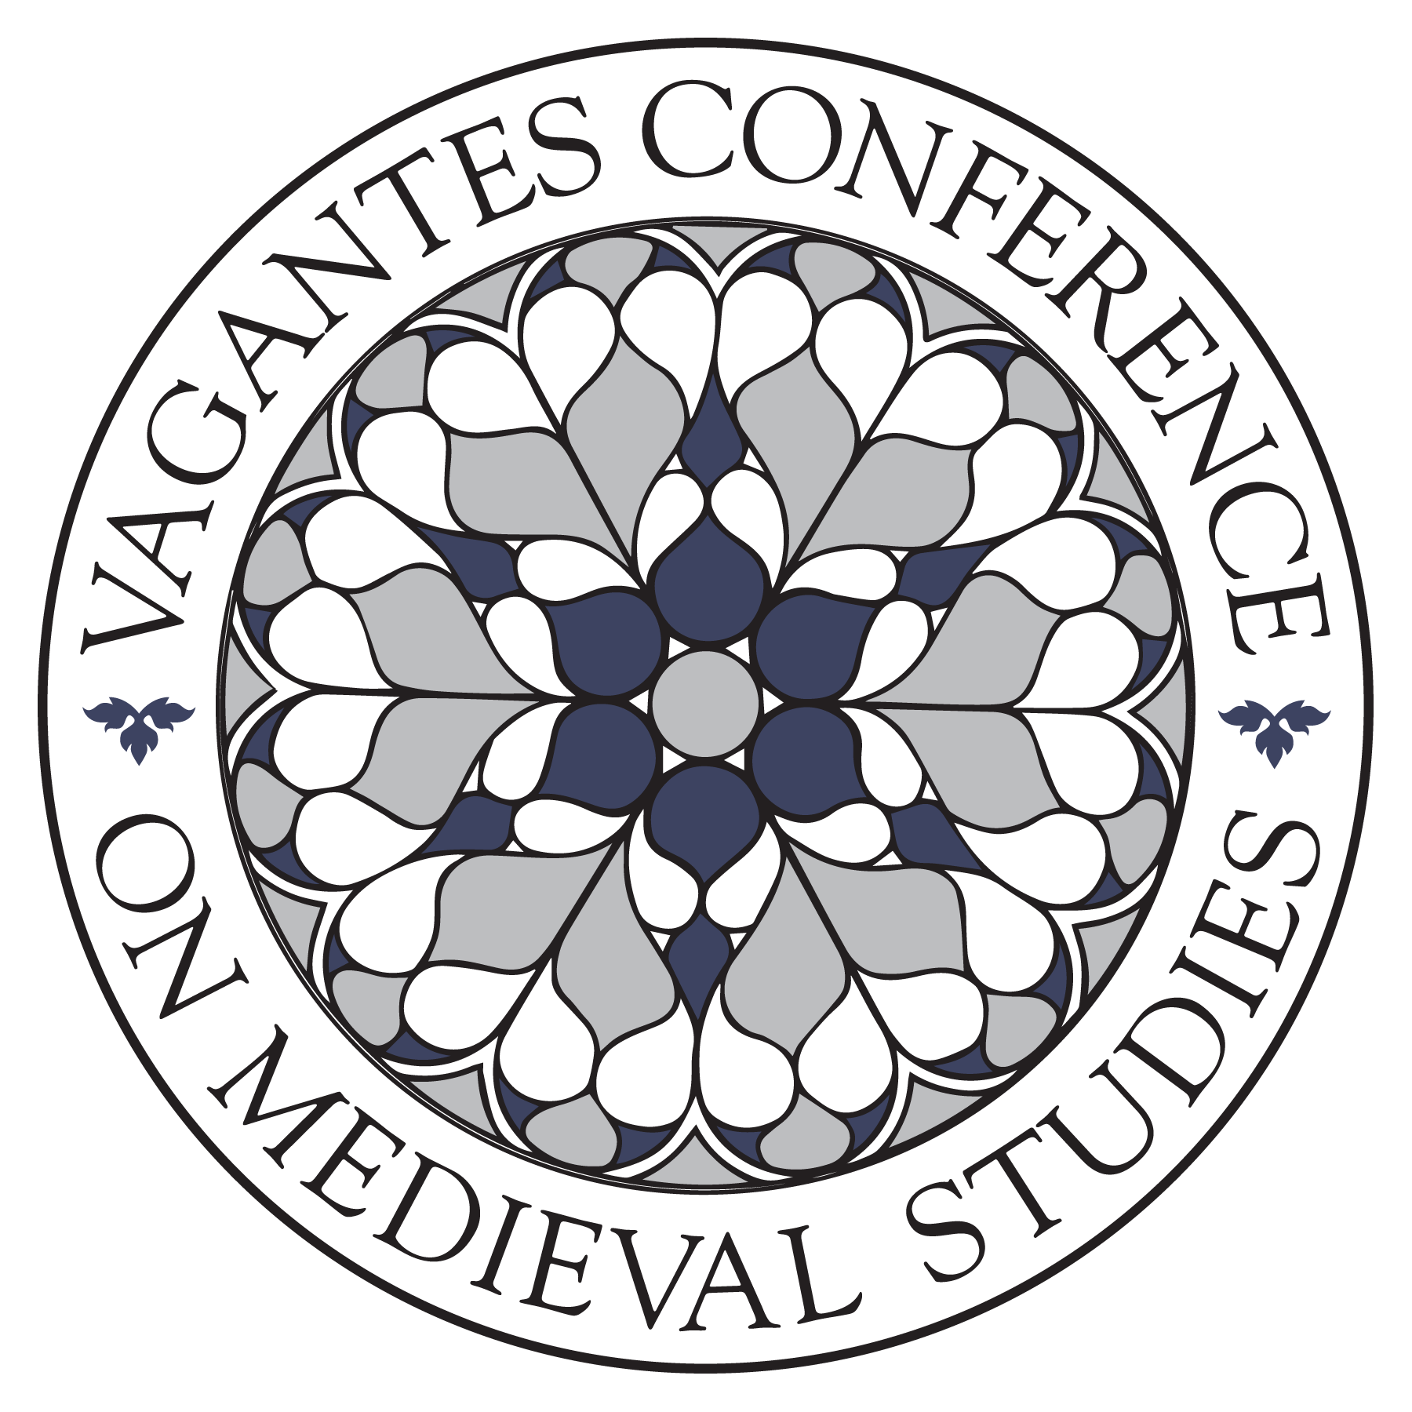

Application to host the 18th annual Vagantes conference in 2019
The Vagantes Conference on Medieval Studies is now accepting applications for our 2019 host institution. The conference is an itinerant, interdisciplinary graduate student conference focusing on the Middle Ages, and is entirely organized and run by graduate students. Vagantes in a unique opportunity to showcase the Medieval Studies community at your institution, as well as to gain valuable professional development experience in planning and organizing the event, and to meet and interact with top medievalist graduate students. Applications will be accepted until Wednesday May 3, 2017 and will be reviewed by the Vagantes Board of Directors, comprised of eight medievalist graduate students. Applications will be discussed at the Annual International Congress on Medieval Studies in Kalamazoo, MI, where the Board may have additional questions for the applicants before reaching a decision. E-mail submissions are required.

Complete this form and send to Margie Housley (mhousley@nd.edu).

a) Name of university (can be a joint application with more than one university)

b) Names of departments, institutes, and student organizations potentially involved

c) Short statement of interest (Why would your school be a good location? What resources do you have available – student interest, funding possibilities, museums, libraries, special exhibitions, etc.? Why would your school be a good venue – accessibility, accommodations, transportation options, etc.?)

d) The costs associated with hosting Vagantes have varied over the years, but on average have required an investment of about $10,000. How does your institution plan to raise this sum? Please name the chief sources of funding you plan to rely upon to pay for the conference.

e) Signatures and institutional affiliations of 5 graduate students who, by signing, will undertake the serious commitment of time to organize the conference if chosen. Please indicate (and provide an e-mail address for) one of the students who, if your university is chosen, will become the official host representative and immediately take up a three-year position on the Vagantes Board of Directors.

f) Name of a faculty advisor who has agreed to be involved with Vagantes

Applicants must agree to the following conditions:
a) The conference will be free and registration will be open to the general public.

b) The conference will run from a Thursday-Saturday in or around March 2019.
c) The 2019 conference will include a keynote by a faculty member from the 2019 host institution and a keynote by a faculty member from the 2020 host institution.

d) The conference will conclude with a final banquet.

e) Your school will send a faculty member to serve as a keynote for the 2018 conference at the University of Minnesota. You will provide the University of Minnesota’s organizers with the speaker’s name and contact information no later than August 15th, 2017.
g) Each year, the abstract submission review committee is comprised of members from the past host institution, current host, and future host institution. Three graduate students from your school must agree to serve as abstract submission readers in November 2017. Three graduate students will also read abstracts in November 2018 and 2019 (these may be, but are not required to be, the same students).
h) The host institution representative from your school must agree to serve a three-year term on the Vagantes Board of Directors.
- Year 1: the position of Future Host Institution Representative on the Vagantes Board of Directors begins as soon as the new host institution is named (c. June 2017). Conference preparations begin.
- Year 2: the position becomes Current Host Institution Representative in May 2018 and continues until May 2019. Conference preparations continue; hosting the event occurs in or around March 2019.
- Year 3: in May 2019 the Current Host Institution Representative becomes the new Chair of the Vagantes Board of Directors and serves in that capacity until May 2020. The Chair is primarily an advisory role. The Chair ensures a smooth transition to the new host institution and supervises the operations of the Vagantes Conference on Medieval Studies and its governing body. Consult the Vagantes Conference on Medieval Studies constitution online or email Margie Housley (mhousley@nd.edu) for further details.

The Future Host Institution Representative or their designee should plan to attend the Board of Directors meeting at the University of Minnesota (a virtual meeting is possible). In addition to submitting proposals to present papers, students from the future host institution will also be invited and strongly encouraged to chair sessions at the 2018 conference at the University of Minnesota.

Vagantes is an annual, traveling conference for graduate students studying any aspect of the Middle Ages. The conference was conceived with several goals in mind, including fostering a sense of community among medievalists at the early stages of their careers, providing exposure to an interdisciplinary forum, and showcasing the resources of the host institutions, all within a student budget. For more information, visit http://www.vagantesconference.org. Send questions or comments to Margie Housley (mhousley@nd.edu).

